土研暨國震中心－實體IP申請表
Civil Engineering Research Building &
National Center for Research on Earthquake Engineering
Static IP Address Application Form
姓名  Name | 學號  Student ID |  | 指導教授  Advisor |  | 系級  Year | 連絡電話  Tel
研究室房號  Research Room Number | 電子郵件  E-mail |  |  | 使用之網卡號碼  MAC Address
- 用途 (IP usage)

- 請註明使用之設備
(Please specify the type of equipment used by this set of IP address.)
□ 同意 □ 不同意  Approved／Rejected |  | 簽核：指導教授  Assessed by：Advisor

簽准後請交予土研613室李昆霖先生
After filling out the form, please hand it in to your advisor to request for approval and then submit it to Mr. KunLin LI at CERB 613.

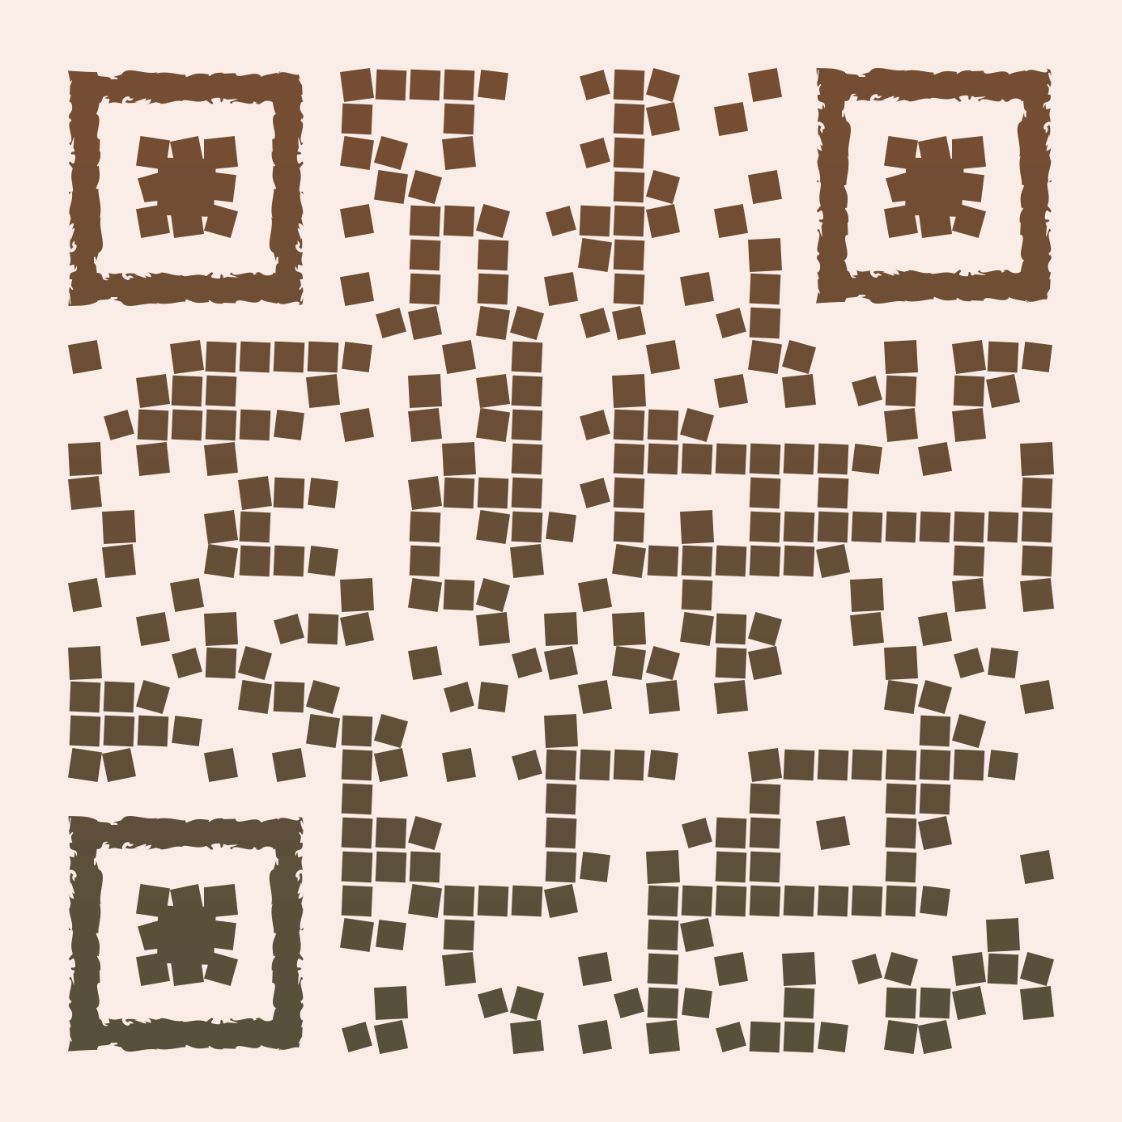
註： 虛擬IP請填寫線上申請表https://tinyurl.com/yc7wpb5s
Note: For dynamic IP, please fill in the online application form

